 Hydrating Cleanser for Normal to Dry Skin 473ML with Hyaluronic Acid and 3 Essential Ceramides

₦16,664

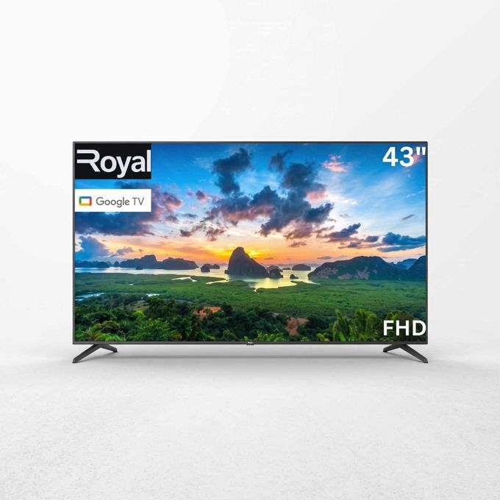

Royal 43" Inches GOOGLE SMART TV (RTV43M10P) + 12 MONTHS WARRANTY
₦ 209,999
​​With built-in Smart TV functionality, you can easily stream content from popular apps, browse the internet, and enjoy on-demand entertainment—all from the comfort of your couch. The Bluetooth feature allows you to connect wireless speakers, soundbars, or headphones for an enhanced audio experience without the clutter of cables.
Its sleek, modern design complements any living space, while multiple connectivity options ensure easy connection to gaming consoles, USB devices, and external media players. The Royal 43" Smart + Bluetooth TV combines performance, style, and convenience for everyday entertainment.

Specifications

Key Features
- 43 -inch Full HD display for clear, vivid visuals
- Smart TV with access to streaming apps and online content
- Bluetooth connectivity for wireless audio devices
- Multiple HDMI and USB ports for versatile connections
- Sleek, slim design suitable for wall-mounting or stand use

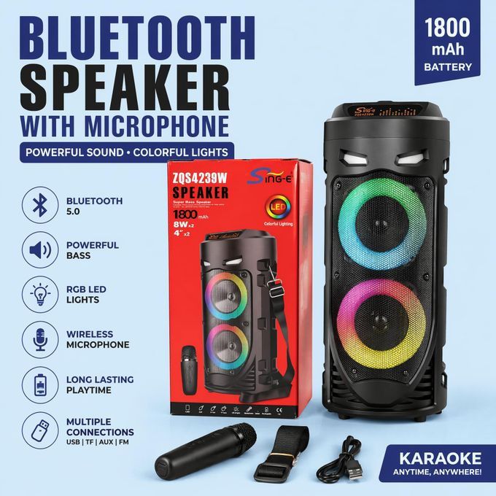

Portable Bluetooth Party Speaker with Wireless Microphone, RGB LED Lights, Bluetooth 5.0, 1800mAh Battery, FM Radio, USB/TF/AUX Support, Karaoke Sound System

₦ 32,400

Bring The Party Anywhere!
Turn every gathering into an unforgettable experience with this powerful Bluetooth Party Speaker. Designed for music lovers and karaoke enthusiasts, it delivers rich bass, clear vocals, and vibrant RGB lighting that moves with your music.
Whether you're hosting a birthday party, family gathering, church event, outdoor picnic, or karaoke night, this speaker provides the sound and energy you need.
The included wireless microphone lets you sing, make announcements, or entertain friends without being tied down by cables. Bluetooth 5.0 technology ensures fast pairing and stable wireless streaming from your smartphone, tablet, or laptop. Multiple playback options including USB, TF Card, AUX, and FM Radio give you complete freedom to enjoy your favorite music. Similar portable karaoke speakers commonly support Bluetooth streaming, USB/TF playback, microphone input, and RGB lighting for entertainment use.
The built-in 1800mAh battery keeps your music playing wherever you go, while the colorful LED light rings create an exciting party atmosphere day or night.
Main Highlights
Powerful Stereo Sound
Enjoy loud, clear audio with enhanced bass performance for music, movies, and karaoke.
Wireless Microphone Included
Sing your favorite songs, host events, or make announcements with ease.
RGB LED Light Show
Dynamic colorful lighting effects create a fun party atmosphere.
Bluetooth 5.0 Technology
Fast pairing and stable connection with smartphones, tablets, and laptops. Bluetooth 5.0 is widely used in modern party speakers for reliable wireless audio streaming.
Multiple Playback Modes
Supports:
Built-in 1800mAh battery allows portable use without constant charging.
Portable Design
Convenient carry strap makes it easy to take anywhere.
Specifications
Product Type: Bluetooth Party Speaker
Bluetooth Version: 5.0
Battery Capacity: 1800mAh
Speaker Size: 4" × 2 Drivers
Lighting: RGB LED Lights
Microphone: Wireless Microphone Included
Connectivity: Bluetooth / USB / TF Card / AUX / FM
Power Supply: Built-in Large Capacity Battery
Color: Black
Suitable For: Home, Outdoor Parties, Karaoke, Events, Gatherings
What's In The Box
1 × Bluetooth Party Speaker
1 × Wireless Microphone
1 × Carry Strap
1 × Charging Cable
Bluetooth Speaker, Karaoke Speaker, Wireless Microphone Speaker, Party Speaker, Portable Speaker, RGB LED Speaker, Outdoor Speaker, FM Radio Speaker, Bass Speaker, Bluetooth Karaoke Machine, Wireless Music Speaker, Party Box Speaker, Home Entertainment Speaker.

Specifications

Key Features
-Feature 1 | Balanced Deep Bass Stereo Sound
Equipped with dual speaker drive units to output full and mellow bass sound, delivering wide-range stereo audio effect. Suitable for family singing, outdoor parties, square activities and daily music playback, bringing comfortable listening experience for all age groups.
Feature 2 | Wired Microphone For Home Karaoke
This audio set comes with a dedicated wired microphone, supporting vocal track elimination function to mute vocal track audio. You can hold home KTV activity with your family freely, and the built-in mic also supports clear hands-free calling.
Feature 3 | Dynamic RGB Flashing Party Lights & Multi Play Modes
Colorful RGB lights shift with music rhythm to build lively party atmosphere. It supports Bluetooth wireless connection, TF card MP3 playback and FM radio, you can play music via multiple ways without mobile phone restriction.
Feature 4 | Built-in Power Cell Portable Design
Fitted with large built-in power supply unit for long continuous playback time. Compact lightweight body with reserved shoulder strap hole, easy to carry for camping, travel, outdoor gatherings and daily indoor use.

What’s in the box
- - K Song Artifact: Comes with a wired microphone, making it the ultimate karaoke companion for home parties and gatherings.
- Super Volume & Heavy Bass: Dual speaker drivers deliver powerful, room-filling sound with deep, punchy bass.
- Vocal Track Elimination: Features a key to hide the vocal track, allowing you to sing along as the lead vocalist.
- Square Volume: Designed to fill large open spaces, ideal for square dancing, outdoor events, and public performances.
- Dynamic LED Lights: Built-in colorful LED lights sync with the music, creating a vibrant party atmosphere.
- Battery: 18650 3.7V/1200mAh
- Accessories: Type-C charging cable, shoulder strap, wireless microphone
- Material: Plastic + metal mesh

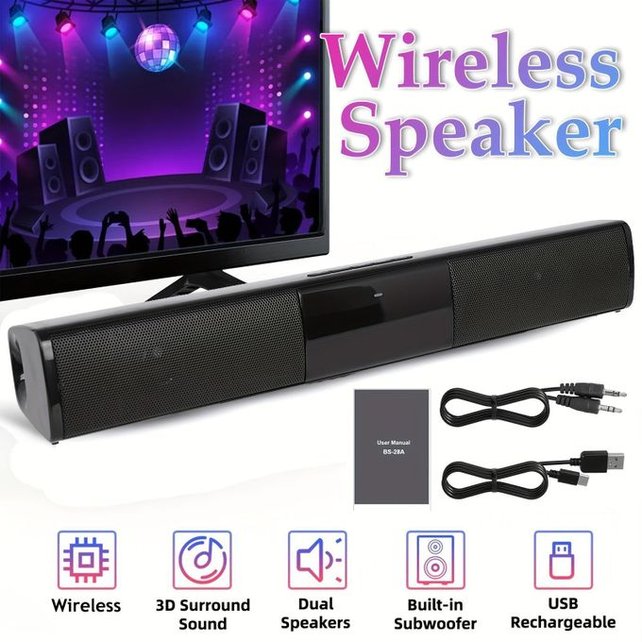

Multifunctional wireless Bluetooth soundbar, 3D surround sound TV home theater speaker
₦ 30,067
₦ 72,00058%

Elevate Your Audio Experience – Cinematic Sound in a Compact Design!
Upgrade your home entertainment with our Professional Wireless Soundbar. Equipped with dual 5W high-performance stereo speakers and a two-sided sound tube design, this soundbar delivers crystal-clear 3D surround sound and deep, rich bass that brings your movies, music, and games to life. Its sleek, 12.99-inch compact body fits perfectly under your TV or computer monitor, making it an ideal choice for saving space without compromising on audio quality.
Versatile Connectivity & Premium Craftsmanship: Designed for the modern lifestyle, this speaker supports multiple input modes, including Bluetooth, USB disk, TF card (up to 32GB), and AUX, allowing you to switch songs at will. The high-light body with a premium metal mesh and silicone anti-slip mats reflects high-quality craftsmanship that complements any decor. With its built-in rechargeable battery, you can enjoy your favorite playlist everywhere—from the living room to outdoor gatherings.
- Product Specifications:
- Audio Output: Dual 5W Stereo Speakers (10W Total)
- Dimensions: 12.99 x 1.96 x 2.16 inches (33 x 5 x 5.5 cm)
- Connectivity: Bluetooth Wireless, USB, TF Card, 3.5mm AUX
- Supported Formats: MP3, APE, FLAC, WAM, WAV
- Build Material: Alloy Metal Mesh + High-Light Body + Silicone Buttons

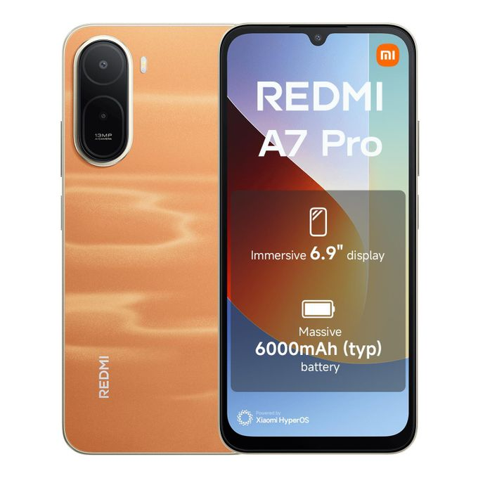

XIAOMI REDMI A7 PRO - 6.9'' 4GB RAM/128GB ROM - Sunset Orange
Brand: XIAOMI | Similar products from XIAOMI
₦ 145,182
₦ 156,1097%

Key Features
- Type: 6.9' LCD Display
- 13MP AI dual camera, 8MP front camera
- 1/3.06" sensor size
- Refresh rate: Up to 120Hz
- Xiaomi HyperOS 3
- Powerful octa-core processor
- Memory: 4GB /128GB, Supports memory extension: 4GB up to 8GB
- Dual SIM + Memory Card
- Battery Capacity: 6000 mAh
- Type: 15W
- Fast Charging: Yes
- AI Features: Google Gemini, Circle to Search with Google, AI Sky
- Side fingerprint sensor, AI Face Unlock

What’s in the box
Mobile Phone | USB Type-C Cable | SIM Eject Tool | Quick Start Guide and Warranty Card | Safety Information

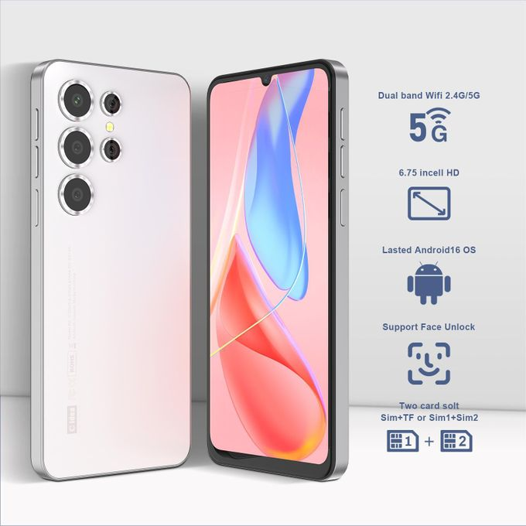

C Idea 6.7 Inches Smartphone,with android10 snapdragon processor,720*1600incell dual Sim 8+64GB
Brand: C Idea | Similar products from C Idea
₦ 84,000
₦ 143,00041%

Convenience at Your Fingertips
Unlock instantly and securely with fast fingerprint and face recognition, making access smoother than ever.

6.7-inch Immersive Display
Featuring an IPS HD screen with 720×1600 resolution for delicate and realistic colors. Enjoy an immersive visual experience whether you’re watching movies, gaming, or working.

Excellent Performance
Powered by a Snapdragon 615 octa-core processor, 8GB（4GB+4GB） RAM, and 64GB storage. Handles multitasking with ease and stores plenty of apps, games, and HD videos seamlessly.

Dual-Camera HD Photography
13MP rear camera + 5MP front camera with intelligent beauty mode. Capture clear photos and enjoy sharper video calls and live streams.

4G High-Speed Connectivity
Supports 4G LTE for fast internet anywhere. Switch seamlessly between work and entertainment on the go.

Long-Lasting Battery with Fast Charging
A 3700mAh high-capacity battery supports all-day use. The USB-C port with 5V/3A fast charging powers up your device more efficiently.

Android 10 System
A safer, smoother operating system compatible with a wide range of apps and games. Download all you like from the Google Play Store.

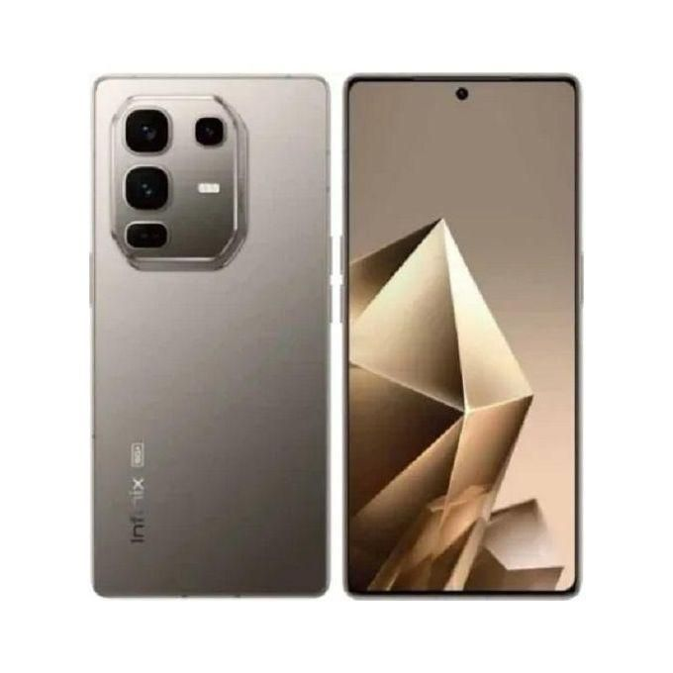

Infinix Note 50 Pro 6.78” X6855 – 8GB RAM, 256GB ROM, 50MP Camera, 5200mAh, 90W Fast Charge
Brand: Infinix | Similar products from Infinix
₦ 498,000
₦ 978,00049%
The Infinix Note 50 Pro features a 6.78-inch 144Hz AMOLED display, a 50MP OIS main camera, and a 32MP selfie camera, driven by a MediaTek Helio G100 chipset with up to 16GB total RAM and 256GB storage. It includes a 5,200mAh battery with 90W fast charging and is available in multiple colors.
Key Features & Gallery Highlights
- Camera: 50MP Main Camera with OIS (Optical Image Stabilization) for sharper, steady shots.
- Selfie Camera: 32MP front-facing camera.
- Display: 6.78-inch FHD+ AMOLED screen with a 144Hz refresh rate.
- Design: Features a 90W All-Round FastCharge 3.0 and a 30W wireless magnetic charging option (MagCharge).
- Performance: Powered by the MediaTek Helio G100 processor with 8GB or 12GB RAM variants. TT

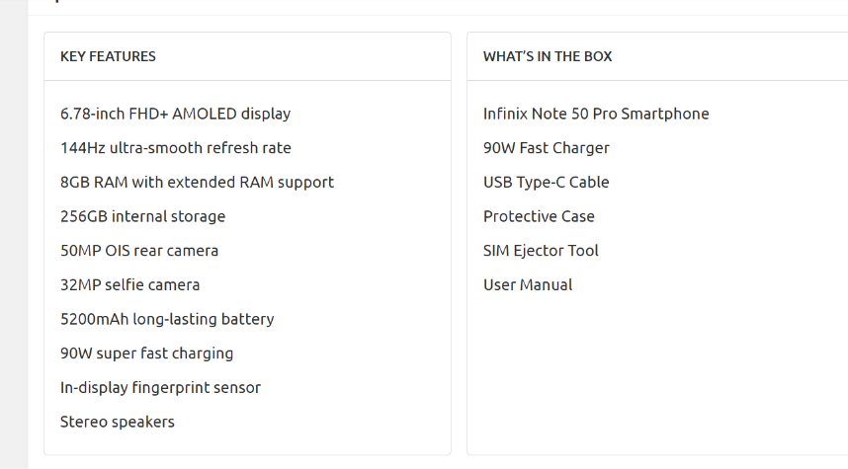

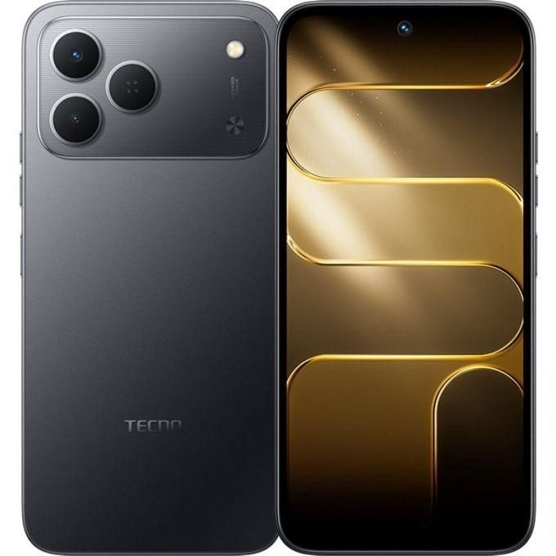

Tecno Spark 50 6.67" 4GB RAM/128GB ROM Android 16 – Black

₦ 225,000
₦ 470,00052%

roduct details
Experience seamless performance and long-lasting power with the TECNO Spark 50 4G. Designed for users who want speed, storage, and stunning visuals, this smartphone comes packed with 128GB of internal storage and 4GB of RAM, ensuring smooth multitasking and ample space for apps, photos, and videos.
The expansive 6.78-inch display with a 120Hz refresh rate delivers ultra-smooth scrolling and vivid visuals, perfect for gaming, streaming, and browsing. Capture every detail with the 50MP rear camera and enjoy extended usage with the massive 6700mAh battery that keeps you connected all day. Running on Android 16, this device brings the latest features, security, and a user-friendly experience right at your fingertips.
Whether you’re a multitasker, gamer, content creator, or social media enthusiast, the TECNO Spark 50 4G combines performance, battery life, and photography in one sleek package.

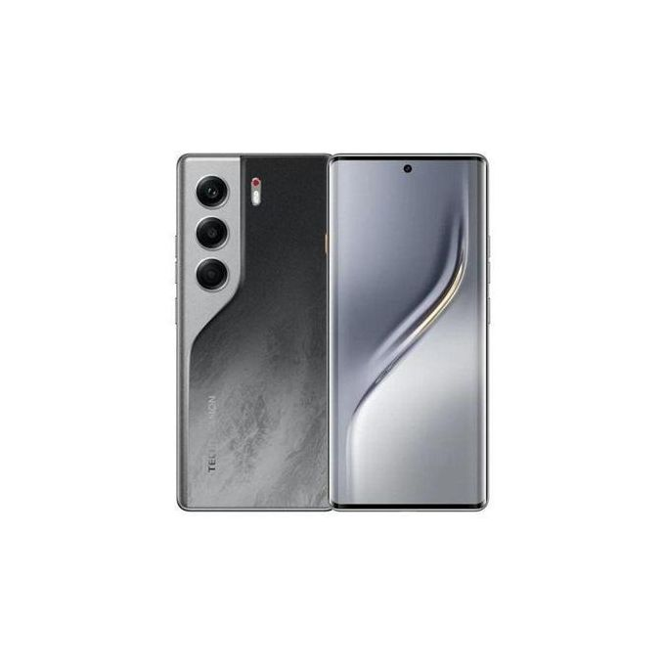

Tecno CAMON 40 Pro - 6.78" (8GB/256GB) 4G Dual SIM, 5200mAh - Black

Share this product

Brand: Tecno | Similar products from Tecno
₦ 488,999
₦ 850,00043%

120Hz Ultra-bright AMOLED Giant Screen, Clear, and Smooth
The ultra-clear full screen has a 94% high screen-to-body ratio with extremely narrow left and right bezels. The 120Hz high refresh rate screen ensures a smooth and fluid experience during system operation.
One-Tap Button, Quick Options at Your Fingertips
The One-Tap Button provides exceptional convenience. A double-press allows for quick startup of FlashSnap. A long-press wakes up Ella, which recommends personalized AI services.
XDR
Give Rebirth to Light and Colors
50MP Sony's LYT-700C Ultra Night Camera, Ultra Sensing, Ultra Shots
Sony's LYT-700C 50MP Ultra Night Camera features extraordinary light sensitivity. With a 1/1.56" large sensor and 2.0μm fused pixels, it delivers exceptional image quality. It excels in day and night shooting. 8MP Ultra-wide Angle Camera, AI Distortion Correction. The 8MP wide-angle camera offers a broad view for group photos, fitting more people. With face optimization and anti-distortion at the edges, the direct output is great.
50MP Selfie Camera
The 50MP selfie camera supports autofocus and eye tracking. The 91.6-degree ultra-wide field of view is great for group photos. With AI portrait distortion correction, both selfies and group shots look natural.
Multi-Focal Length Portrait, Framing Portrait Moments at Different Focal Lengths
The phone is armed with a multi-focal length portrait camera. Swift switching between focal lengths precisely captures character-environment interactions, framing wonderful portrait moments

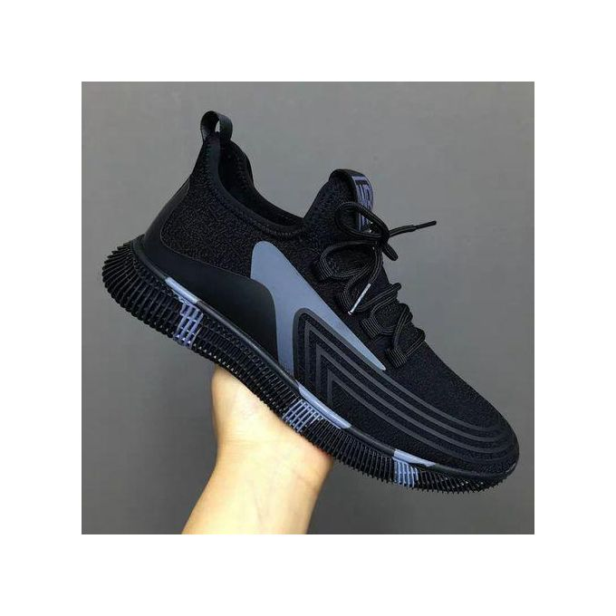

Footwear - Casual Shoes Fasion Canvas Quality and Affordable
₦ 7,440
₦ 15,600 - ₦ 28,60074%
Have you ever had the saying "the right pair of shoes can help you conquer all"
Well, your search is at an end because These pairs of shoes are classic pair of shoes made with the finest material of:
· Polyester (upper body part)-for quick dry (in cases of emergency), flexibility and shrink resistant
· Cotton (lower body part)-comfortable, lightweight and easy to clean.
· synthetic material sole: which is lightweight, flexible, relatively soft, absorb shock and help you avoid fatigue.
On top of that the polyester/cotton body part has microscopic holes ventilate your feet under hot temperature and keep your feet dry.
These sneakers are also designed to fit and make you standout in any occasion whether you are going for the work casual look or just going out with your friends
Name it, whatever occasion this shoe is sure to meet your taste.
PRODUCT DESCRIPTION
You can't go wrong with these pair of shoes, made with best design and excellent splashes of color, the basic design of this shoe is to suit your every occasion whether it is going to crash a club or feeling simple this shoe will fit and perfectly suit your every occasion specially made to keep your feet comfortable throughout the day.
Made from durable polyester fabric, these slip-on pair is perfect for both men and women and can be paired with a variety of casual attire. These low heel canvas are stylish, comfortable and trendy.

This classy footwear gets the attention of on-lookers with its trendy and gorgeous finish you can coordinate with matching and off-color outfits. The durable heel is evenly balanced for comfortable movement and easy traction.
The soft, comfortable and breathable fly woven upper material gives your leg room to breathe, it is soft and protective to cushion your every step, even to your ankle. Lightweight with excellent bounce-back and durability. Adapts to the ground with stability. This pair features the versatility and comfort needed in every casual footwear.

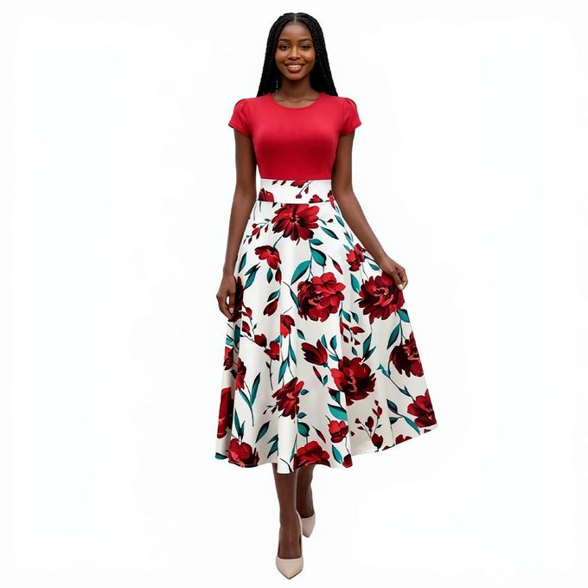

Red Floral Print Maxi Dress Women - Color Block Short Sleeve Long Gown
₦ 11,520
₦ 14,40020%

Red Floral Print Color Block Maxi Dress

This stunning maxi dress combines a bold red bodice with a flowing white skirt featuring large red floral prints. The unique color block design creates a chic two-piece look, while the wavy waist seam adds a stylish detail that sets this dress apart.

The round neck and cap sleeves with princess seam detailing create a clean, structured silhouette that flatters every figure. Crafted from soft polyester and milk silk blend fabric, the dress feels silky smooth against the skin and drapes beautifully to ankle length. Weighing only 260g, it is incredibly lightweight yet substantial enough for a premium feel.

The breathable fabric with slight stretch keeps you comfortable all day long. Perfect for church services, wedding guests, parties, or any special occasion where you want to stand out.

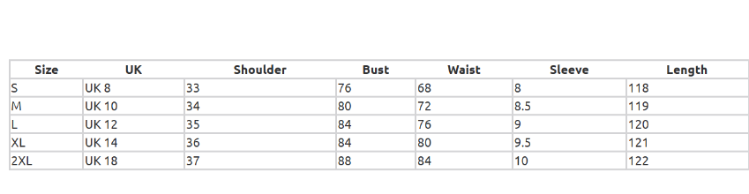

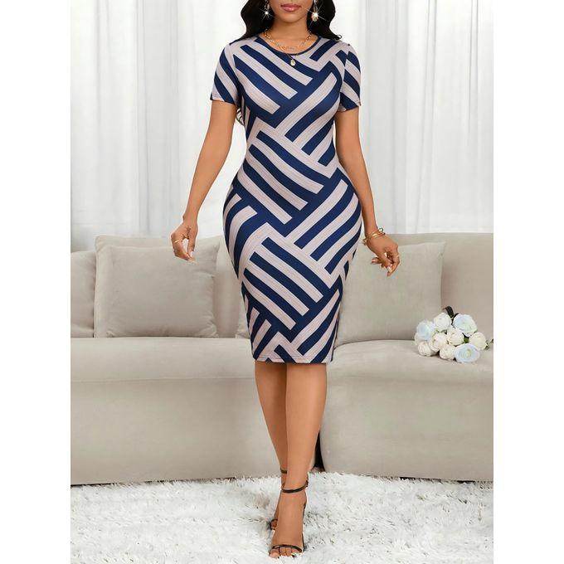

Elevate your wardrobe with this sophisticated geometric print bodycon midi dress, designed for women who love timeless style and effortless comfort. Crafted from soft, stretchy, and breathable fabric, it delivers a flawless curve-hugging fit that accentuates your figure, making it perfect for all-day wear.
The dress features a classic round neckline, short sleeves, and a sleek pencil silhouette that falls to a chic midi length. The standout detail is the modern diagonal stripe geometric print in deep blue and neutral tones, creating a polished, professional look that transitions seamlessly from the office to evening outings.
Ideal for a wide range of occasions, this dress is your go-to choice for office work, business meetings, romantic dates, casual gatherings, and special events. Pair it with heels for a formal office look, or dress it down with flats for a chic casual vibe.
All measurements are in centimeters (cm).
Size Difference: The gap between adjacent sizes is calculated as (Larger Size - Smaller Size).
Measurement Deviation: Please allow 1-3cm difference due to manual measurement.
Fit Tip: If you prefer a loose fit, we recommend choosing one size up.



Women's Black White Striped Sleeveless Bodycon Mini Dress - Casual Summer Tank Dress
₦ 9,360
₦ 15,12038%
Some variations with low stock

Elevate your casual wardrobe with this timeless striped bodycon mini dress, designed for effortless style and all-day comfort. Crafted from soft, stretchy, ribbed fabric, it delivers a flawless curve-hugging fit that accentuates your figure, making it ideal for hot weather and everyday wear.
The dress features a classic round neckline, sleeveless tank design, and a sleek mini length, paired with a timeless black and white striped pattern that never goes out of style. This versatile piece transitions seamlessly from casual daytime outings to evening dates and weekend parties, making it a must-have in your closet.
Pair it with sneakers for a laid-back street style look, or dress it up with heels for a glamorous night-out vibe, and own every moment with confidence.
All measurements are in centimeters (cm). Size Difference: The gap between adjacent sizes is calculated as (Larger Size - Smaller Size). Measurement Deviation: Please allow 1-3cm difference due to manual measurement. Fit Tip: If you prefer a loose fit, we recommend choosing one size up.

Specifications

Key Features
Timeless Striped Print: Classic black and white stripes for a chic, versatile look
Flattering Bodycon Fit: Sleeveless tank design that hugs your curves perfectly
Summer-Ready Style: Perfect for daily wear, dates, parties and casual outings
Soft Ribbed Fabric: Stretchy, breathable material for all-day comfort
Trendy Mini Length: Sleeveless round neck design for a modern, feminine vibe

Home and Appliance’s

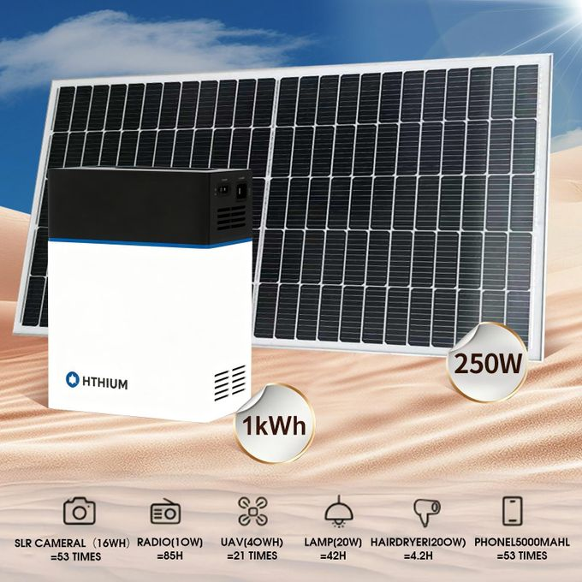

HITHIUM HEROEE1 1kWh Portable Power Supply Power Station And 250W 33V Monocrystalline Solar Panel Set for Home Backup&Outdoor

₦ 330,000

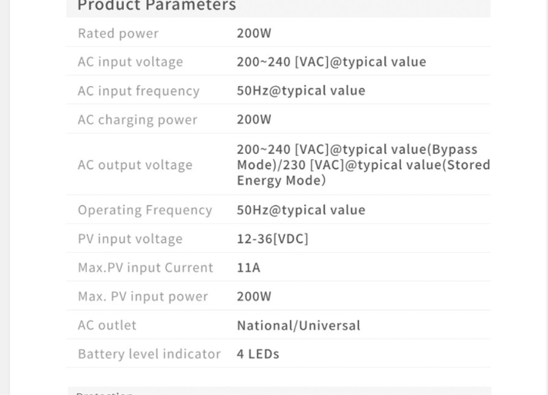
\

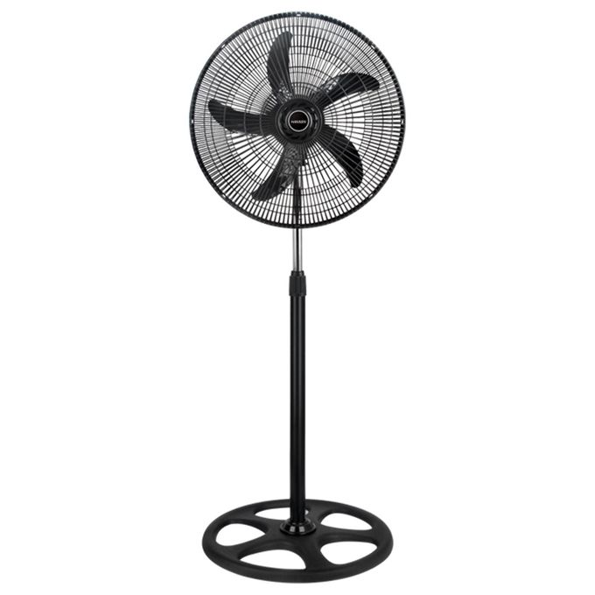

HANSEN 18 inches industrial level standing fan

Skincare and . BeautySkincare and . Beauty

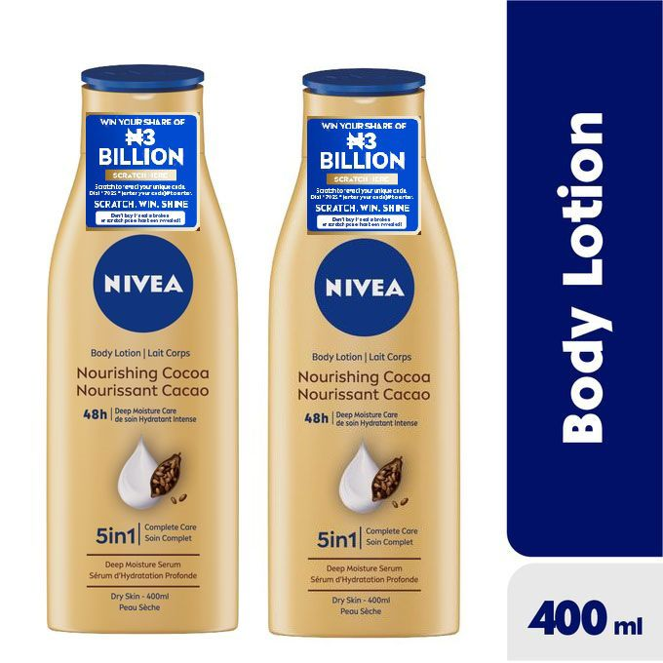x

NIVEA Nourishing Cocoa Body Lotion For Women - 400ml (Pack Of 2)

₦ 6,780

NIVEA Nourishing Cocoa Body Lotion provides 48h nourishing deep moisture care and noticeably smoother skin. The patented formula is using the knowledge, that our skin contains sufficient moisture in its deeper layers. The unique composition of skin’s own moisturizer, moisture-locking lipids and care providing oils bind and hold water in the skin thus the moisture cannot evaporate easily into the surrounding area. The skin is well protected from drying out, because water loss is reduced and the moisture level of the skin is increased.
The latest testing methods have shown that the perfect combination of high quality ingredients of our body milk and lotions together with the DEEP MOISTURE SERUM penetrates deeply into the skin, locking moisture and providing deep moisture for 48h. An effect you can not only feel but also see.
- 48h nourishing deep moisture care
- DEEP MOISTURE SERUM and cocoa butter & vitamin E
- Provides moisture and smoothes away dullness
- Leaves skin nicely fragranced with a scent of cocoa - after just 1 application.
- With Cocoa Butter



West Month Pore-Cleansing Essence Toner Pads - Purify, Tighten Pores, Brighten & Refresh Skin for Clear Complexion
₦ 5,398
₦ 13,50060%
Product Name: Pore Cleansing Essence Toner Cotton Pads
Specification: 70pieces
Gross Weight: 110g
Ingredients: AQUA, GLYCERIN. HYDROXYETHYLCELLULOSE. HAMAMELIS VIRGINIANA (WITCH HAZEL) EXTRACT. CHRYSANTHELLUM INDICUM EXTRACT
Package Size: 7.4x7.3x7.3cm
Product Size: Bottle: 7.2x7.1x7.1cm Cotton Pad: 5.7x5.7cm



Orange Vintage Double-Bridge Sunglasses, Stylish Minimalist Oversized Comfortable Shades - Unisex, with Case
₦ 2,179
₦ 9,00076%

Beauty Formulas Vitamin E Exfoliating Facial Scrub, 150ml
₦ 4,835

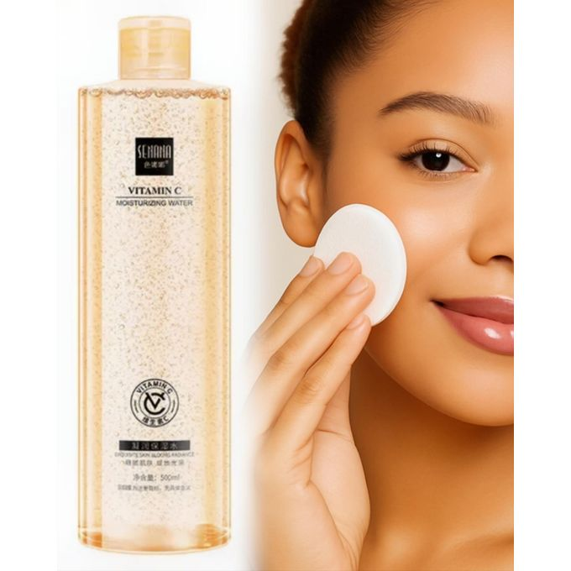Vitamin C Brightening Hydrating Anti Dark Spots Face Toner 500ml
₦ 5,115
₦ 9,50046%
Vitamin C Brightening Hydrating Anti Dark Spots Face Toner 500ml
Vitamin C Brightening Hydrating Anti Dark Spots Face Toner 500ml
Reveal smoother and more radiant skin with the Vitamin C Brightening Hydrating Anti Dark Spots Face Toner. This gentle yet effective toner is enriched with vitamin C, hyaluronic acid, and natural skin-brightening extracts that help fade dark spots, even out skin tone, and restore your skin’s natural glow. It hydrates deeply while balancing oil and water levels, making it the perfect prep step before your serum or moisturizer.
Daily sunscreen use is strongly recommended when using brightening products to protect your results and prevent sun-triggered pigmentation.

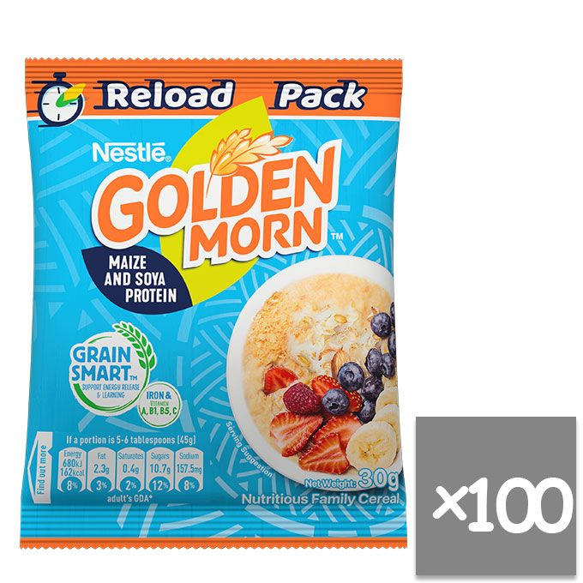

Nestle Golden Morn Grainsmart 30g x100
Brand: Nestle | Similar products from Nestle
₦ 20,325
₦ 32,08137%



Indomie REGULAR CHICKEN 120G (Super Pack) - 1 Carton
Brand: Indomie | Similar products from Indomie
₦ 17,000
₦ 22,74425%



Golden Penny Macaroni -500g
Brand: Golden Penny | Similar products from Golden Penny
₦ 2,500

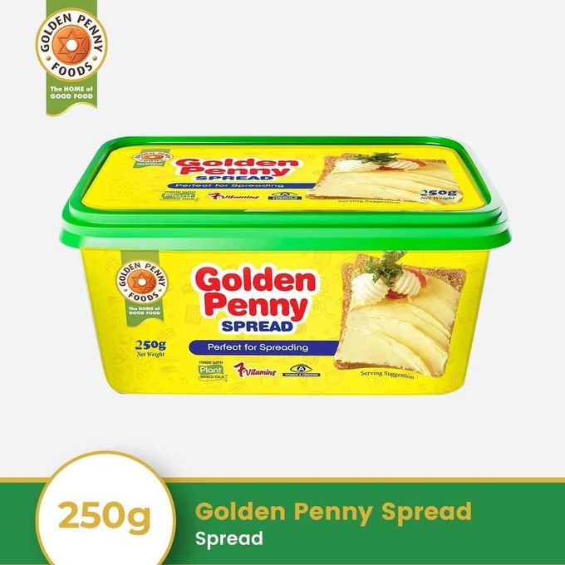

Golden Penny Spread -250g
Brand: Golden Penny | Similar products from Golden Penny
₦ 2,605
₦ 2,8007%

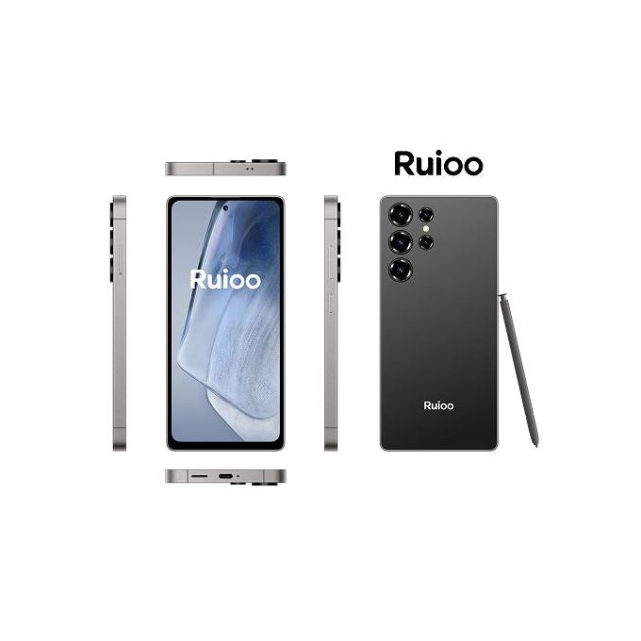

Ruioo RUIOO S25 Ultra Android Smartphone 8GB + 128GB 6.8 inches
Brand: Ruioo | Similar products from Ruioo
₦ 99,991
₦ 144,00031%

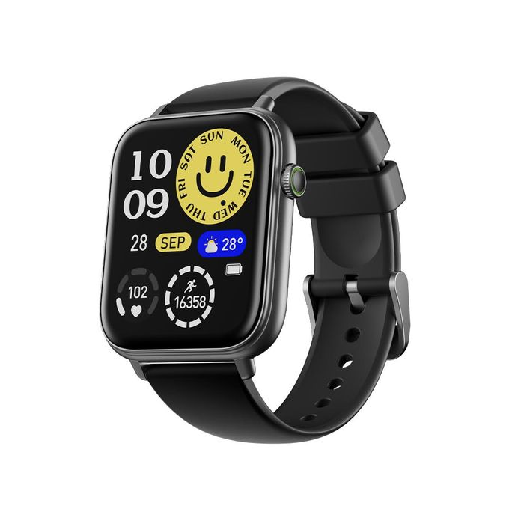

Specifications

Key Features
- AI Generated Watch Faces
- Anti Scratch Panda Glass
- Blood Oxygen and Heart rate Monitor
- Ip68 Waterproof

Specifications
- SKU: OR537EA83W49PNAFAMZ
- Model: Watch 6N
- Weight (kg): 0.10

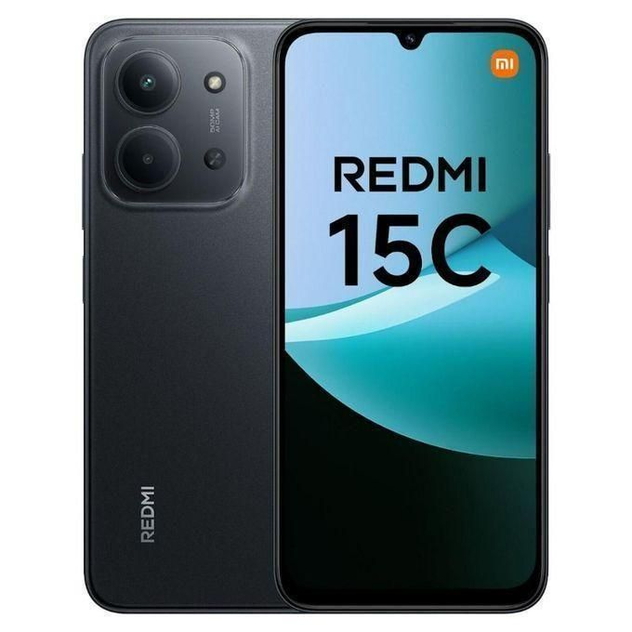

XIAOMI Redmi 15C 6.9'' 6GBRAM/128GB ROM Android 15 -Midnight Black
Brand: XIAOMI | Similar products from XIAOMI
₦ 182,182
₦ 195,0007%

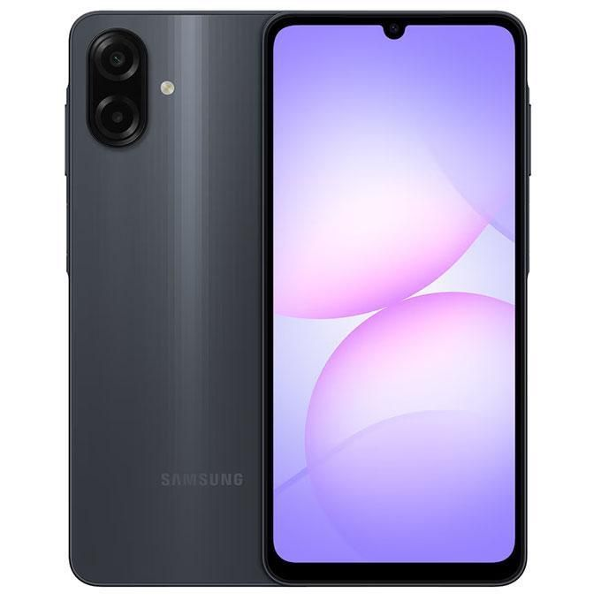

Samsung Galaxy A07 6.7" 4GB RAM/128GB ROM - Black

Samsung Galaxy A07 6.7" 4GB RAM/128GB ROM - Black

Product details
In terms of specifications, the Galaxy A07 aims to provide essential features suited for everyday use. It is rumored to include IP54 dust and splash resistance in certain markets, offering added durability. The camera setup features a dual rear arrangement with a 50MP wide main sensor supported by autofocus and a secondary 2MP depth or macro sensor, depending on the variant. For selfies, the front camera could either be 8MP or 16MP, and both the front and rear cameras support 1080p full-HD video recording, with optical image stabilization reportedly available in select models. Powering the device is a large 5000mAh to 5500mAh battery, depending on the market, with support for 25W fast charging through USB-C, which should comfortably last a full day of use.

